Syria
Ancient Syria, one of the relatively few territories whose name has remained virtually unchanged throughout history, also roughly corresponds to the size of the modern country of the same name. The region was initially dominated by the Hittite culture and fell under the influence of various others such as the Amorites, Egyptians, Assyrians, Babylonians and Persians.
While it was influenced by these cultures, and conducted considerable profitable trade with each, it was also home to one of the ancient world's highly advanced peoples.
The Phoenicians, a mixture of native coastal Syrians and Canaanites of biblical fame, were great contributors to the advancement of human civilization. The Phoenicians were not only the greatest seafaring race of the ancient world, significantly advancing the art of shipbuilding, but improved and developed iron working throughout the east. They also introduced Syria's greatest legacy to human civilization, the 30 letter Semitic alphabet, which formed the basis for the Greek alphabet, and therefore the languages of the western world.
Perhaps even more influential, though it's hard to argue with the development of their alphabet, was the impact of Phoenician colonization. Because of their vast network of sea trade and travel, independent Phoenician city-states were established all over the Mediterranean (discovering the Atlantic Ocean in the process), the most notable being that of Carthage. The Phoenician culture of Carthage flourished, and an empire that reached all corners of Europe and the Mid-East dominated ancient trade.
In Syria itself however, the independence of their culture was under constant strain. The Assyrian King Tiglath-Pileser III overran Syria in the mid 8th century BC and was followed by the Babylonians under Nebuchadnezzar II in the late 7th century. The Persians intervened in the 6th century and would dominate the area for 3 centuries, until the coming of Alexander the Great. Under the Persians, like most of their conquests, the natives were allowed considerable autonomous rule, and the region prospered. This brief respite from foreign conquest was short-lived however, as Alexander invaded and conquered in 333 BC. With him came an immense cultural change, where Western Hellenistic ideas and institutions came to dominate.
Though Alexander died shortly after his conquest in 323 BC, the region continued to fall under the control of Macedonian policy. His General, Seleucas, became heir to the lands and established a three century dynasty that would remain only until their great defeat at the hands of Rome. Under the Seleucids Syria continued to prosper and Greek influence grew considerably. Immigrants flocked to the region and new cities sprung up all over. Trade with European and Middle-Eastern neighbors continued to flourish and Syrian goods reached such far flung places as India and China. Advancement in irrigation, astronomy, philosophy and all the sciences marked Hellenized rule.
The Seleucids, however, fatally misunderstood the growing power of Rome. In the early 2nd century BC, King Antiochus III had achieved great gains for Syria, both to the west and east. Because of repeated disputes between the dynasties established by Alexander's former generals, Macedonia, the Ptolemies of Egypt and the Seleucids, war and territorial jockeying was nearly constant. While the growing Roman power slowly expanded east, after having already defeated Carthage, Antiochus ignored the threat and continued to expand his own borders westward. In 191 BC, a relatively small Syrian army of 10,000 met a Roman force of twice its size at the famous Spartan battlefield of Thermopylae. Under the command of Consul Manius Acilius Glabrio, Antiochus was crushed and was forced to flee back to Asia. Over the course of the next the next year, the Romans pressed their advantage and an army led by Scipio Africanus and his brother Gnaeus overwhelmed a hastily recruited Syrian army at Magnesia. With this defeat, the Seleucid dynasty began to falter and external pressures from Arab Nabataeans, Armenians and the Parthian Empire took its toll.
Within a century, Hellenized rule was virtually in shambles and the east was in complete political disarray. Into the void came Mithridates VI of Pontus, who with his own conquests, drew Rome's eye even farther east. The rampant spread of Piracy along the southern coast of modern Turkey (Cilicia, Lycia and Pamphylia) brought further Roman interference. In 66 BC, a campaign led by Pompey the Great essentially brought the whole region, Syria included, under Roman control. In 64 BC, Syrian Kings were ousted, and Pompey officially annexed Syria as a Roman province.
Under Roman rule, Syria would eventually prosper again. Despite serving as a frontier buffer zone, Syria's ports and trade routes with the far east were important economic forces. Grain, fruits, cloth, glass, wool, linen, textiles, pottery, timber and resin were all exported in abundance. Dyes too, especially the purple dye extracted from mollusks on the Syrian shore were of particular importance.
Much like Syria's entire ancient history, it did remain a battleground territory during the Roman era. Serving as a launching point against Parthia, into Judaea and elsewhere, as many as four legions were garrisoned in Syria at any one time. Legio III Gallica, VI Ferrata, X Fretensis, XII Fulminata, IIII Scythica and XVI Flavia all saw service prior to the split of the eastern and western empires. With that split, and the eventual fall of the West, Syria fell under Byzantine authority, but was under constant pressure from Persians. Eventually, in the 7th century AD, despite strong Christian Orthodox roots, Syria fell to Arab invasions and grew into an Islamic cultural center.

Syrian Wars
IMMACOLATA ERAMO
First published: 03 March 2015

https://doi.org/10.1002/9781118318140.wbra1469
PDF
Tools

Share
The Romans clashed with the Syrian army on two occasions: first, during the conquest of the Mediterranean Sea (the “Syrian War”), then when Pompey annexed Syria as a Roman province (64 BCE), at the end of the Third Mithridatic War. The Syrian War came about as a consequence of Antiochus III's expansionist policy in Greece. The event that led to the outbreak of the war was the Roman intervention in the ensemble of allies in Greece. The first battle took place at Thermopylae (191 BCE). Here Antiochus's strategy was to block Manlius Acilius Glabrio's two legions, preventing any possibility of outflanking, in order to earn time while waiting for reinforcements to arrive from Asia (App. Syr. 17.75). The hills above the chosen site were occupied by 2,000 Aetolians distributed between Kallidromos, Teichios, and Rhoduntia, who had the role of preventing an attack from behind (Livy 36.16.11). The site was entrenched on the side of the sea with a rampart and toward the mountains with a wall (Livy 36.16.1–36.16.2), on which (according to App. Syr. 18.78) the artillery was positioned. The phalanx was deployed near the wall, defended on the left by archers and slingers. On the right, toward the sea, near the rampart and the difficult muddy terrain, it was defended by elephants and cavalry (Livy 36.18.3–36.18.4; App. Syr. 18.83). Antiochus had expected that if his troops resisted the first attack, they would be able to counterattack immediately with the help of the cavalry. If, however, the Romans, after getting through the skirmish of light infantry, had found themselves in front of the wall, they would not have been able to get around it. In fact, the Romans were not able to force their way through (Livy 36.18.5; App. Syr. 19.84). When the light infantry moved backwards and withdrew behind the fortifications, the Romans found themselves in front of the rampart and the wall, and the battle stalled. The battle resumed again because of the assault on Kallidromos's Aetolians conducted by a small detachment led by Marcus Porcius Cato. The Aetolians were taken by surprise while asleep (App. Syr. 18.81; Plut. Cato Mai. 13). At this point the Seleucids, seeing Cato's troops rushing from behind and afraid that the number of enemy troops was greater, fled. They were hindered by the difficult terrain and obstructed by the fortifications that they had built themselves (Livy 36.19.3–36.19.4; App. Syr. 19.87).
The war then moved to Asia where the Romans were the masters of the sea thanks to the victories at Cape Korykos (191 BCE) and Myonnesus (190 BCE). At Cape Korykos, Antiochus's Admiral Polyxenidas was defeated by Caius Livius Salinator and the Rhodian allies because of their use of iron hooks thrown onto the enemy ships at an opportune moment. This transformed the naval battle into a hand-to-hand fight (Livy 36.44; Just. Inst. 31.6.9). In the Battle of Cape Myonnesus, Polyxenidas attempted to take his enemy by surprise, attacking the Roman fleet at midday. However, Lucius Aemilius Regillus realized what was happening in time and deployed his fleet while the Rhodian ally, Eudamos, deployed his ships near the coast. The fire positioned at the prow of the Roman ships was decisive, because the enemy, in order to avoid the fire, was forced to turn its flanks toward the Roman ships. The battle was therefore decided by the maneuver performed by the Roman ships, which from the Syrian left side broke through the center of the enemy fleet and reached the king's ships which were engaged in battle against Eudamos. Polyxenidas decided to retreat (Livy 37.31.6–37.31.8).
Antiochus lost his control of the Aegean Sea and, with all negotiations having failed, the two adversaries decided to go to war. The battle took place at Magnesia ad Sipylum (190). Here the army commanded by Lucius Cornelius Scipio and Gnaeus Domitius Ahenobarbus crossed the Phrygius River and waited for Antiochus, who initially did not rise to the challenge. The Romans, wishing to fight before the winter (Livy 37.37.5), then approached Antiochus where the Phrygius River bent at a 90-degree angle. Antiochus was forced to fight there as he saw that his troops were demoralized and worried that the Romans would attack the camp if they had continued to refuse to fight (Livy 37.39.4; 6). The Roman army was set up in their usual manner: four turmae of cavalry on the left side, near the river (Livy 37.39.11); two legions at the center (Livy 37.39.8) protected on the sides by two wings of Latins; and on the right there were Achaean peltae, 3000 infantrymen and 3000 horsemen with Pergamenian auxiliaries, Trallians, and Cretans (Livy 37.39.9; App. Syr. 31.157). The velites were positioned in front of the legions, performing the traditional role of skirmishers. The Seleucid army was numerous, but haphazard: the heavy infantry was deployed at the center and the elephants were positioned inside a deep phalanx made up of 32 lines. The Galatian infantrymen and the argyraspides were deployed on the right; at the front were mounted troops made up of cataphract cavalry and an elite group of heavy cavalry, the agema (Livy 37.40.5; App. Syr. 6.32), and finally came Dahaean mounted archers, various light infantry, and archers. On the left of the phalanx a mixed force made up of different nationalities was deployed, including cataphract cavalry, Galatian mounted cavalry, and Tarentines. In front of these there were scythed chariots (cited also by Veg. 3.24.1), camels, and light infantry (Livy 37.40; App. Syr. 32). On the left wing, the battle was initiated by the chariots. Due to the fog they became the victims of the very chaos they were intended to provoke (Veg. Mil. 3.24: the Romans used caltrops against the Scythian chariots). Eumenes led archers, slingers, and light infantry against the enemy mounted troops in order to increase the confusion (Livy 37.41.9–37.41.12; App. Syr. 33.172). At this point, the cataphracts, who could not win against a mobile opponent, withdrew, causing the total collapse of the cavalry on the left wing (Livy 37.41.9–37.42.3; App. Syr. 173–176). Antiochus attacked the turmae and the extreme left wing of the legion (Livy 37.42.7–37.42.8; App. Syr. 34.177). The legion, which was initially disarranged, withdrew toward the camp, where it was immediately rearranged by Marcus Aemilius Lepidus (Livy 37.43.1–37.43.5). The Roman skirmishers made the Seleucid promachoi go back between the lines of the phalanx (Livy 37.42.4; App. Syr. 35.178). The phalanx was exposed to the outflanking of the cavalry, which had won on the left side, and to frontal attack by both legions. The phalanx, partly encircled and stormed by arrows and missiles, was withdrawing toward the camp when the elephants, camels, and horses fled in disorder and led to a disorganized withdrawal of the troops (Livy 37.43.9; App. Syr. 35.183). The enemy quarters were plundered and ravaged and Antiochus escaped to Sardis.
See also Greeks; Syria; Wars of the Middle Republic, 201–133 BCE ; Wars against Mithridates.

\Roman Egypt by (Wasson, 2016)
4Save

Definition

by Donald L. Wasson
published on 24 October 2016
Available in other languages: French, Spanish, Turkish
Subscribe to topic Subscribe to author Print Article PDF
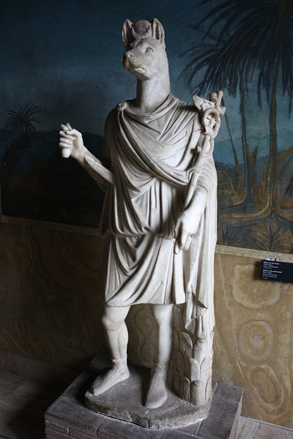
Roman Statue of Anubis
Mark Cartwright (CC BY-NC-SA)

The rich lands of Egypt became the property of Rome after the death of Cleopatra VII in 30 BCE, which spelled the end of the Ptolemaic dynasty that had ruled Egypt since the death of Alexander the Great in 323 BCE. After the murder of Gaius Julius Caesar in 44 BCE, the Roman Republic was left in turmoil. Fearing for her life and throne, the young queen joined forces with the Roman commander Mark Antony, but their resounding defeat at the Battle of Actium in 31 BCE brought the adopted son and heir apparent of Caesar, Gaius Julius Octavius (Octavian), to the Egyptian shores. Desperate, Cleopatra chose suicide rather than face the humiliation of capture. According to one historian, she was simply on the wrong side of a power struggle.

Early Relations with Rome
Rome's presence in Egypt actually predated both Julius Caesar and Octavian. The Romans had been involved periodically in Egyptian politics since the days of Ptolemy VI in the 2nd century BCE. The history of Egypt, dating from the ousting of the Persians under Alexander through the reign of the Ptolemys and the arrival of Julius Caesar, saw a nation suffer through conquest, turmoil, and inner strife. The country had survived for decades under the umbrella of a Greek-speaking ruling family. Although a center of culture and intellect, Alexandria was still a Greek city surrounded by non-Greeks. The Ptolemys, with the exception of Cleopatra VII, never traveled outside the city, let alone learn the native tongue. For generations, they married within the family, brother married sister or uncle married niece.
Ptolemy VI served with his mother, Cleopatra I, until her unexpected death in 176 BCE. Despite having serious troubles with a brother who challenged his right to the throne, he began a chaotic rule of his own. During his reign, Egypt was invaded twice between 169 and 164 BCE by the Seleucid king Antiochus IV; the invading army even approached the outskirts of the capital city of Alexandria; however, with the assistance of Rome, Ptolemy VI regained token control. While the next few pharaohs made little if any impact on Egypt, in 88 BCE the young Ptolemy XI succeeded his exiled father, Ptolemy X. After awarding both Egypt and Cyprus to Rome, Ptolemy XI was placed on the throne by the Roman general Cornelius Sulla and ruled with his step-mother Cleopatra Berenice until he murdered her. Ptolemy XI's ill-advised relationship with Rome caused him to be despised by many Alexandrians, and he was therefore expelled in 58 BCE. However, he eventually regained the throne but was only able to remain there through kickbacks and his ties to Rome.
When the Roman commander Pompey was soundly defeated by Caesar in 48 BCE at the Battle of Pharsalus, he sought refuge in Egypt; however, to win the favor of Caesar, Ptolemy VIII killed and beheaded Pompey. When Caesar arrived, the young pharaoh presented him with Pompey's severed head. Caesar reportedly wept, not because he mourned Pompey's death but supposedly had missed the chance of killing the fallen commander himself. Also, according to some sources, in his eyes, it was a disgraceful way to die. Caesar remained in Egypt to procure the throne for Cleopatra as Ptolemy's actions had forced him to side with the queen against her brother. With the defeat of the young Ptolemy, the Ptolemaic kingdom became a Roman client state, but immune to any political interference from the Roman Senate. Visiting Romans were treated well, even 'pampered and entertained' with sightseeing tours down the Nile. Unfortunately, there was no saving one Roman who accidentally killed a cat - sacred by tradition to the Egyptians - he was executed by a mob of Alexandrians.
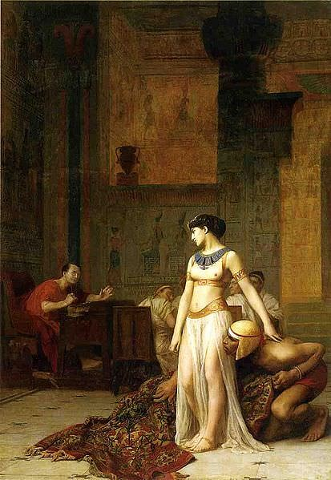
Cleopatra and Caesar
Jean-Léon Gérôme (1824–1904) (Public Domain)

History and Shakespeare have recounted ad nauseam the sordid love affair between Caesar and Cleopatra; however, his unexpected assassination forced her to seek help in safeguarding her throne. She chose incorrectly; Antony was not the one. His arrogance had brought the ire of Rome. Antony believed Alexandria to be another Rome, even choosing to be buried there next to Cleopatra. Octavian rallied the citizens and Senate against Antony, and when he landed in Egypt, the young commander became the master of the entire Roman army. His victory over Antony and Cleopatra awarded Rome with the richest kingdom along the Mediterranean Sea. His future was guaranteed. The country's overflowing granaries were now the property of Rome; it became the 'breadbasket' of the empire, the 'jewel of the empire's crown.' However, according to one historian, Octavian believed that Egypt was now his own private kingdom, he was the heir of the Ptolemaic dynasty, a pharaoh. Senators were even prohibited from visiting Egypt without permission.

Egypt Becomes a Roman Province
With the end of a long civil war, Octavian had the loyalty of the army and in 29 BCE returned to Rome and the admiration of its people. The Republic had died with Caesar. With Octavian - soon to be acclaimed as Augustus - an empire was born. It was an empire that would overcome poor leadership and countless obstacles to rule for almost five centuries. He would restore order to the city, becoming its 'first citizen,' and with the blessing of the Senate, govern without question. Upon his triumphant march into the city, the emperor displayed the spoils of war. The conquering hero adorned in a gold-embroidered toga and flowered tunic rode through the city streets in a chariot drawn by four horses. Although Cleopatra was dead (he had hoped to display and humiliate her in public), an effigy of the late queen, reclining on a couch, was placed on exhibit for all to see. The queen's surviving children, Alexander Helios, Cleopatra Selene, and Ptolemy Philadelphus (Caesarion had been executed), walked in the procession. Soon afterwards, Augustus ordered the immediate construction of both a temple deifying Caesar (built on the spot where he had been cremated) and a new Senate house, the Curia Julia; the old one had been torched following Caesar's funeral.
Remove Ads
Advertisement
The country's overflowing granaries were now the property of Rome; it became the 'breadbasket' of the empire, the 'jewel of the empire's crown.'
Emperor Augustus took absolute control of Egypt. Although Roman law superseded all legal Egyptian traditions and forms, many of the institutions of the old Ptolemaic dynasty remained with a few fundamental changes in its administrative and social structure. The emperor quickly filled the ranks of the administration with members of the equestrian class. With a flotilla on the Nile and a garrison of three legions or 27,000 troops (plus auxiliaries), the province existed under the leadership of a governor or prefect, an appointee (as were all major officials) of the emperor. Later, since the region saw few outside threats, the number of legions was reduced. Strangely, the first governor, Cornelius Gallus, unwisely made 'grandiose claims' about his victorious campaign into the neighboring Sudan. Augustus was not happy, and the governor mysteriously committed suicide - the area's frontier would thereafter remain fixed.

Social & Cultural Divisions
Egyptian temples and priesthoods kept most of their privileges, although the imperial cult did make an appearance. While the mother-city of each region was permitted partial self-government, the status of many of the province's major towns changed under Roman occupancy with Alexandria (the city's population would reach 1,000,000) enjoying the greatest concessions. Augustus maintained a registry of the 'Hellenized' residents of each city. Non-Alexandrians were simply referred to as Egyptians. Rome also introduced a new social hierarchy, one with serious cultural overtones. Hellenic residents - those with Greek ancestry - formed the socio-political elite. The citizens of Alexandria, Ptolemais, and Naucratis were exempt from a newly introduced poll-tax while the 'original settlers' of the mother-cities were granted a reduced poll-tax.
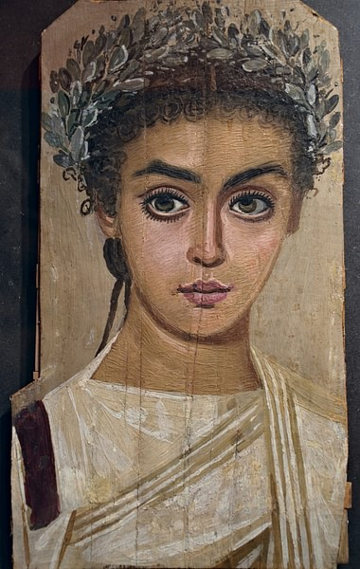
Mummy Portrait of a Girl
Carole Raddato (CC BY-SA)

The main cultural separation was, as always, between the Hellenic life of the cities and the Egyptian-speaking villages; thus, the bulk of the population remained, as it had been, the peasants who worked as tenant farmers. Much of the food produced on these farms was exported to Rome to feed its ever-growing population. As it had for decades, the city needed to import food from its provinces – namely Egypt, Syria, and Carthage - to survive. The food, together with luxury items and spices from the East, ran down the Nile to Alexandria and then to Rome. By the 2nd and 3rd centuries CE, large private estates emerged operated by the Greek landowning aristocracy.
Remove Ads
Advertisement
Over time this strict social structure would be questioned as Egypt, Alexandria especially, saw a significant change in its population. As more Jews and Greeks moved into the city, problems arose that challenged the patience of the emperors in Rome. The reign of Emperor Claudius (41-54 CE) saw riots emerge between the Jews and the Greek-speaking residents of Alexandria. His predecessor, Caligula, stated that the Jews were to be pitied, not hated. Later, under Emperor Nero (54-68 CE) 50,000 were killed when Jews tried to burn down Alexandria's amphitheater – two legions were necessary to quell the riot.

Attitude Towards Roman Control
Initially, Egypt was accepting of Roman control. Its capital of Alexandria would even play a major role in the ascendancy of one of the empire's most famous emperors. After the suicide of Nero in 68 CE, four men would vie for the throne – Galba, Otho, Vitellius, and Vespasian – in what became known as the Year of the Four Emperors. In the end, the battle fell to Vitellius and Vespasian. With hopes of delaying valuable shipments of grain to Rome, Vespasian traveled to Alexandria. At the same time, Mucianus, a Roman commander and ally of Vespasian, marched into Rome. The defeated Vitellius was captured, and while pleading for his life, dragged through the streets, tortured, and killed. His body was thrown into the Tiber. Still in Alexandria, the armies of Vespasian unanimously declared him emperor.
In 115 CE, however, there were a number of Jewish riots in Cyrenaica, Cyprus, and Egypt, voicing discontent with Roman rule and rampaging against pagan sanctuaries. The riots were eventually suppressed by Roman troops; however, thousands of Romans and Greeks were killed in what became known as the Babylonian Revolt or Kitos War. Dissatisfaction with Roman control became part of the Egyptian psyche. Until the fall of Rome in the west, revolt and chaos would haunt the Egyptian prefects. In the early 150s CE, Emperor Antonius Pius quelled rebellions in Mauretania, Dacia, and Egypt. Over a century later, in 273 CE, Emperor Aurelian suppressed another Egyptian uprising. After the division of the empire under Diocletian, revolts broke out in 295 and 296 CE.
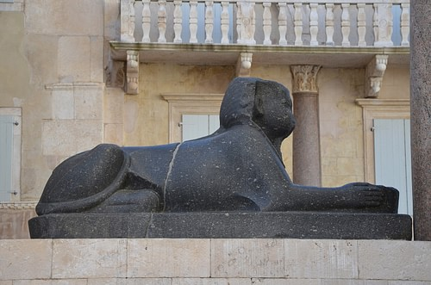
Egyptian sphinx from Diocletian's Palace
Carole Raddato (CC BY-SA)

Remove Ads
Advertisement
Two major disasters hit Egypt, disrupting Roman control. The first was the Antonine plague of the 2nd century CE, but the more serious of the two came in 270 CE with an invasion from the unlikeliest of all invaders, Queen Zenobia of Palmyra, an independent city on the border of Syria. When its king Septimius Odaenathus died under suspicious circumstances, his wife took charge as regent, leading an army in the conquest of Egypt (she ousted and beheaded its prefect), Palestine, Syria, and Mesopotamia and proclaiming her young son Septimus Vaballathus emperor. One action that brought the ire of Rome came when she cut off the city's corn supply. The new emperor of Rome, Aurelian, would finally defeat her in 271 CE. Her death, however, is shrouded in mystery. One story had the emperor bringing her to Rome as a prisoner (she was given a private villa) while another has her dying en route to the city.

The End of Roman Egypt
When emperor Diocletian came to power in the late 3rd century CE, he realized that the empire was far too big to be ruled efficiently, so he divided the empire into a tetrarchy with one capital, Rome, in the west and another, Nicomedia, in the east. While it would continue supplying grain to Rome (most resources were diverted to Syria), Egypt was placed in the eastern half of the empire. Unfortunately, a new capital in the east, Constantinople, became the cultural and economic center of the Mediterranean. Over time the city of Rome fell into disarray and susceptible to invasion, eventually falling in 476 CE. The province of Egypt remained part of the Roman/Byzantine Empire until the 7th century when it came under Arab control.

Cleopatra the Great: Last Power of the Ptolemaic Dynasty by (Bianchi, 2025)
By Bob BianchiFondation Gandur pour l’Art, Genève
The famous scene of Cleopatra emerging from an unrolled rug, popularized by playwright George Bernard Shaw, is based on an ancient account but tweaked for dramatic effect. The anecdote is one example of many contrasts between this famous queen’s image and her life as we know it today. In truth, Cleopatra enlisted the services of a trusted servant to carry her, bundled in dirty laundry, past palace guards and into Julius Caesar’s presence.
Cleopatra must have been petite to be so concealed and carried. The popular belief that she was an exceptional beauty is a narrative based on ancient sources. Cleopatra VII was identified with the Egyptian goddess, Isis, who is equated with Aphrodite and Venus. During her sojourn in Rome, Caesar dedicated a golden statue of the queen in the temple of Venus. The comparison implies Cleopatra VII must have resembled the classical goddesses of love. But unlike the image portrayed most noticeably by actress Elizabeth Taylor in the famous 1963 film, Cleopatra, I envision Cleopatra VII as a wiry, small-boned woman – a picture supported by numismatic images and at least one posthumous Pompeian wall painting.
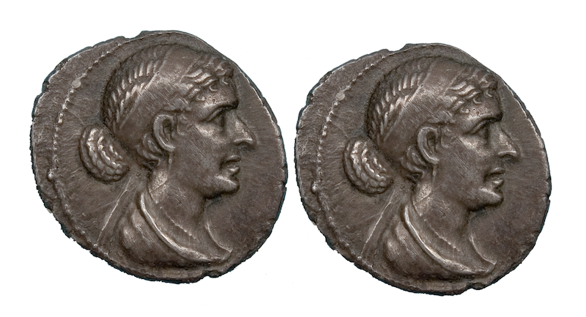Coin with an image of Cleopatra VII
Photo: The Fan Museum Trust
Following the death of her father, Ptolemy XII Auletes, Cleopatra ascended to the throne in 51 BCE with one of her younger brothers as co-regent. The 18-year-old queen found herself embroiled in court intrigue and soon was ousted from Alexandria, the capital of her realm. She gained support from the Roman ruler, Caesar, and the pair defeated her brothers and their supporting coteries. From that moment until her death by suicide almost 20 years later, Cleopatra VII ruled her kingdom with little sedition or revolt, although she had to contend with the expansion and power of Rome.
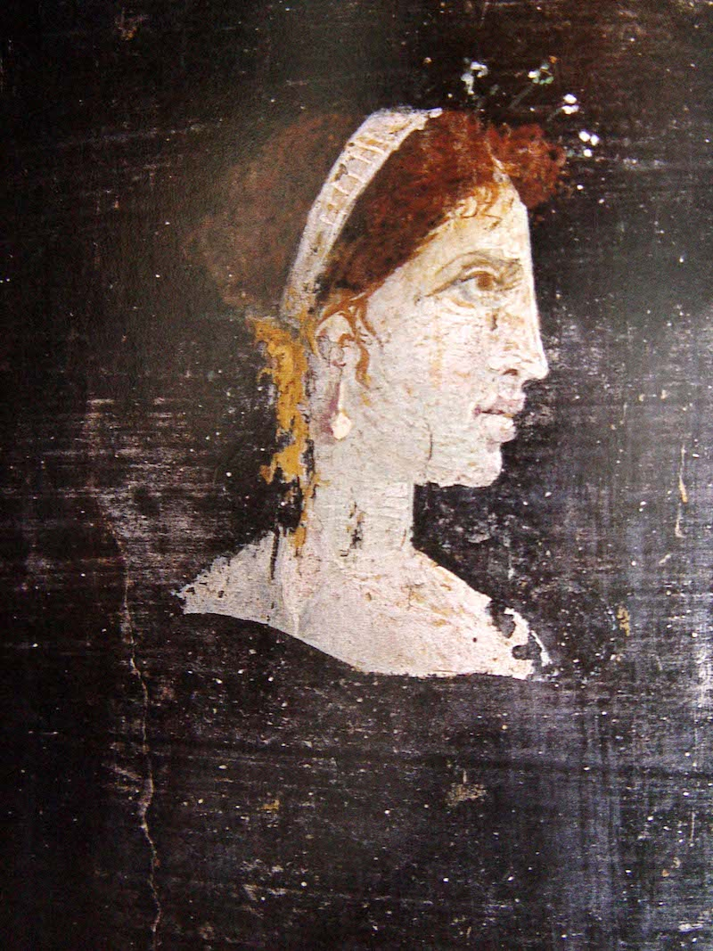Detail of a wall painting, perhaps depicting Cleopatra VII, from either Herculaeum or Stabiae
Photo: Naples National Archaeological Museum, John Ward Perkins and Amanda Claridge
The queen’s command of language and magnetic personality attracted all those in her presence. Cleopatra VII was literate in ancient Egyptian and conversed with Aethiopians, Troglodytes, Hebrews, Arabians, Syrians, Medes and Parthians in their native languages. The sound of her voice was compared to a melodious, multi-stringed musical instrument. In addition to her linguistic skills, the ancients praised her intellect and ascribed to her treatises on such diverse subjects as cosmetics, coinage, chemistry and gynecology.
Documented monetary reform supports the ancient tradition that Cleopatra VII wrote treatises on coinage and on weights and measures. She strengthened her nation’s economy by making explicit the fiduciary nature of the bronze coinage in circulation, the value of which was determined by Cleopatra and not based on weight. The result of this reform approximated the value of her bronze coinage to the Roman denarius, the contemporary currency of choice throughout the Western world.
The queen played an active role in the administration of her realm, confirmed by a papyrus written in Greek. That document, like a present-day inter-office memo, was written to Cleopatra VII by a high-ranking Alexandrian court official. It contains an annotation in Greek, “Make it happen!,” that is attributed to Cleopatra herself. While not exactly an autograph, the subscription is a rare example of a note handwritten by an ancient monarch.
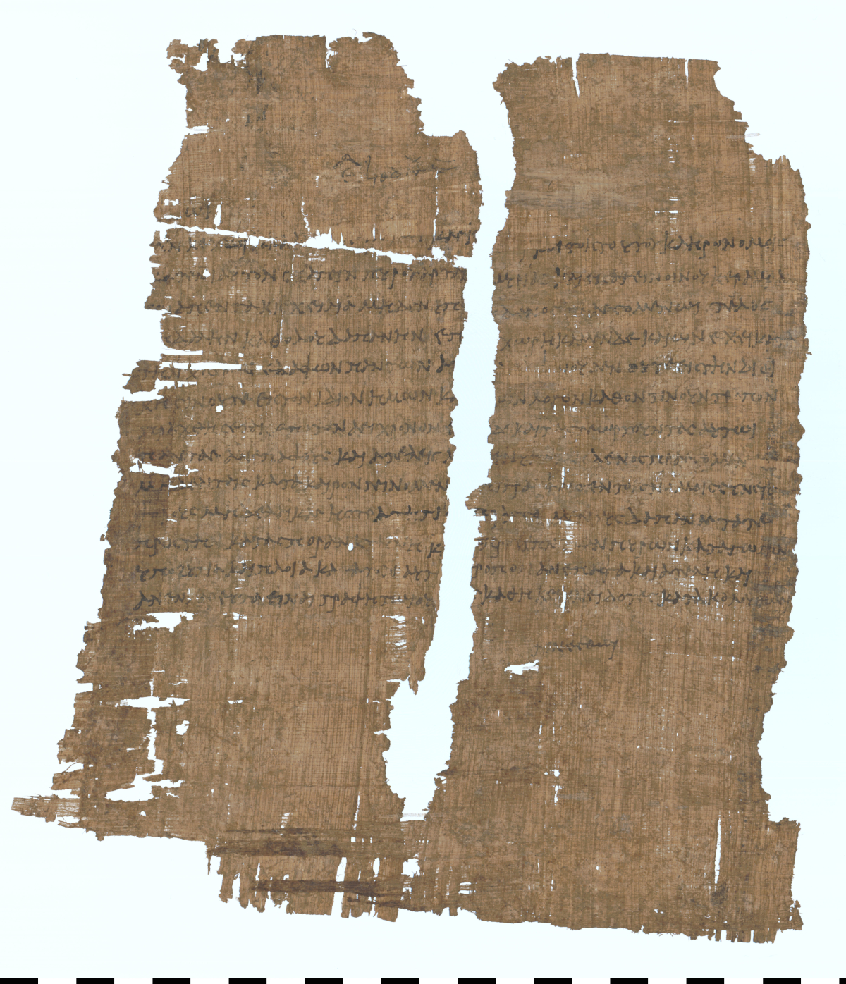Greek papyrus with a subscription attributed to Cleopatra VII herself, Staatliche Museen zu Berlin – Ägyptisches Museum und Papyrussammlung
Photo: Berliner Papyrusdatenbank P 25239
The remarkable events of Cleopatra’s life include a child with the later-assassinated Caesar, plus her marriage and children with the Roman, Marc Antony. Antony and Cleopatra’s forces were defeated by Octavian’s army at the Battle of Actium in 31 BCE and assured the end of her reign. The queen’s suicide at age 39 is the stuff of legend. Tradition maintains that she experimented with condemned prisoners to find the most painless lethal poison, and ultimately elected to end her life by venom at a temple to the goddess Isis in Alexandria. Whether she was bitten by one or more serpents may never be determined, but what’s certain is that Cleopatra chose to die for her principles rather than surrender.
Popularists have repeatedly misunderstood the presence and roles of Cleopatra’s manicurist and hair dresser during her final moments. They were not ensuring their queen looked attractive in death. On the contrary, her suicide was a staged ritual by which she strove in death to deprive the Romans of her capture. According to pharaonic Egyptian practices dating back to the third millennium BCE, royal court officials included barbers and manicurists. They collected clipped hair and nails for ritual disposal, lest they fall into hostile hands to the detriment of their owner. In death, Cleopatra VII reaffirmed her command of pharaonic, Egyptian cultural norms.
Cleopatra VII had grown antagonistic with Rome, and literary testimony shows she was subject to scorn, ridicule and hate after her suicide. Her fate was just the opposite in Egypt, where her pharaonic subjects strove to preserve her memory. Her faithful administrator, Archibios, offered the Romans 2,000 talents to save her statues from destruction. And in 373 CE, centuries after her death, the Egyptian priest, Petesenufe, overlaid a statue of Cleopatra with gold. Cleopatra VII was an educated, disciplined monarch whose beneficial reign was long-remembered and cherished by her subjects.
Topics

